**ICS4U1**

2013

**ControlPoint**

**A Remote Administration Tool**

**Tim Salomonsson**

User Manual

Contents

Outline 3

Server-side 3

Client-side 3

Procedures 4

Viewing Connected Clients 4

Managing Clients 4

Viewing Remote System Information 4

Searching for Clients 4

Administrative Functions 5

Retrieving the Remote Date 5

Taking a Screenshot 5

Sending a System Command 5

Password Generation 5

Reference Materials 5

# Outline

## Server-side

The server side of ControlPoint consists of the management interface. Here is where administration of all remote clients occurs.

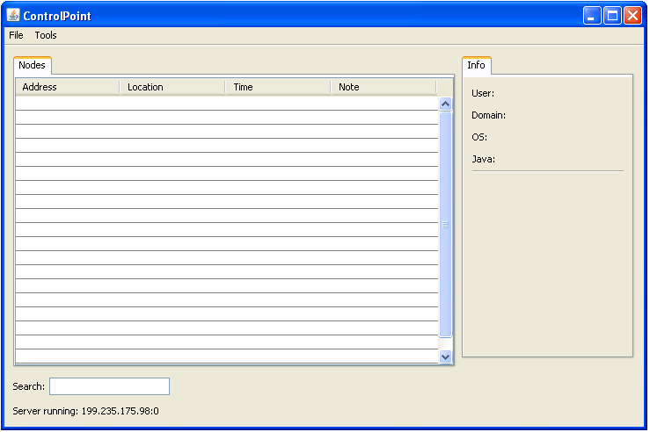

The port upon which the server listens is specified in the configuration file: control-config.txt, in the main program folder.

## Client-side

The client part of the application displays a button that allows connects the client to the server. The IP address and port to connect to is specified in the configuration file: client –config.txt in the main program folder.

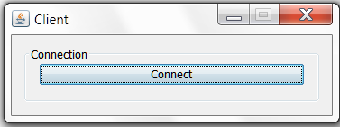

The client app must be executed from inside an IDE by running the file named ClientInterface.

# Procedures

## Viewing Connected Clients

Client connections automatically update on the user interface upon connection.

## Managing Clients

The administrative functions available for each client can be displayed by right clicking on a client connection in the table.

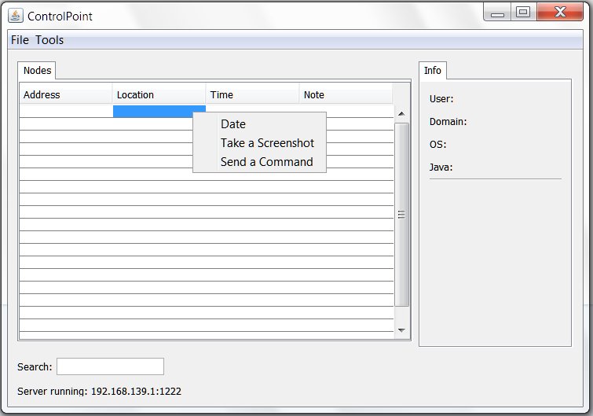

## Viewing Remote System Information

The system information of the currently selected client is automatically updated in the pane to the right of the table.

## Searching for Clients

The search bar on the bottom left of the interface allows the user to search by IP address. The desired connection in the table is automatically selected.

# Administrative Functions

## Retrieving the Remote Date

Clicking the date function in the context menu retrieves the remote date and displays it in the table.

## Taking a Screenshot

Clicking the screenshot function in the context menu retrieves an image of the remote screen and displays in a new window.

## Sending a System Command

Clicking the command function in the context menu sends a command to the remote system and displays the command output in a new window.

## Password Generation

Pressing Ctrl + G will open a password generation window. Here the user can specify the desired password length and a random password is displayed.

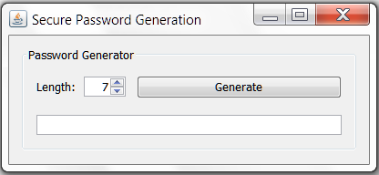

## Reference Materials

|  |  |
| --- | --- |
| **Function** | **Keyboard Shortcut** |
| Shutdown the server | Ctrl - E |
| Password generation | Ctrl - G |